


GOVT.DEGREE COLLEGE
MYDUKUR-516172

DEPARTMENT OF ECONOMICS

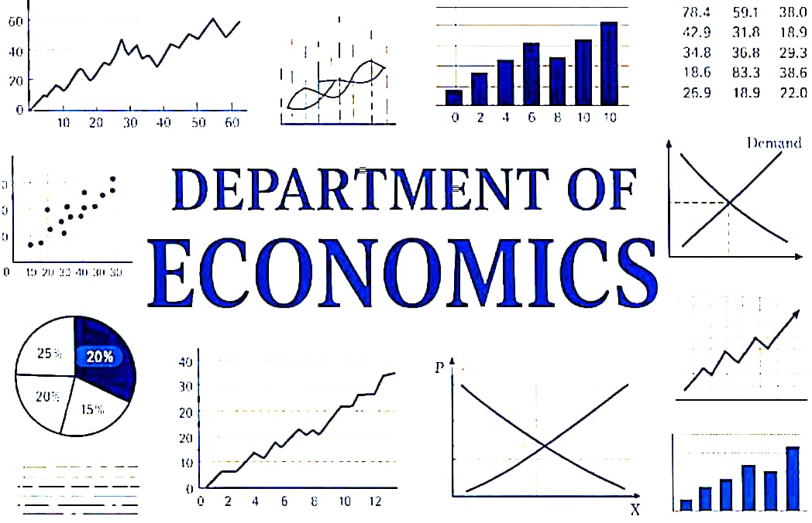
BEST PRACTICES

Academic Year: 2025-2026

1-Best Practice: Clean and Green Campus Initiative
Department: Department of Economics
Institution: Government Degree College Mydukur
Location: Mydukur

1. Title of the Practice
Clean and Green Campus – Environmental Awareness and Campus Beautification

2. Objectives
- To promote environmental awareness among students.
- To maintain a clean and healthy campus environment.
- To encourage students to participate in community service and environmental protection.
- To develop a sense of social responsibility and teamwork among students.
- To improve the green cover of the college campus through tree plantation.

3. Context
A clean and green environment is essential for a healthy learning atmosphere. The Department of Economics initiated a Clean and Green Campus program where students actively participate in campus cleaning, removal of waste, and plantation of saplings. This initiative helps create awareness about environmental sustainability and encourages students to take responsibility for maintaining the college surroundings.

4. The Practice
- Students and faculty participate in campus cleaning drives.
- Removal of plastic waste and unwanted materials from the campus.
- Tree plantation and watering of plants to increase greenery.
- Awareness discussions on environmental protection and sustainable development.
- Regular monitoring and maintenance of the planted saplings.
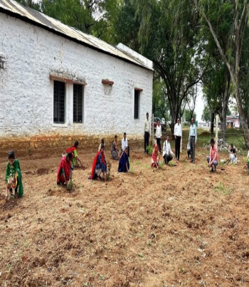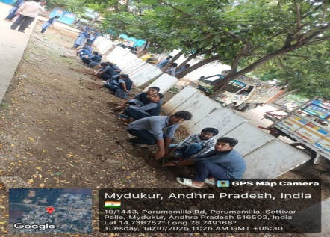
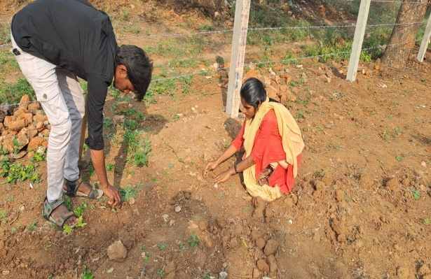
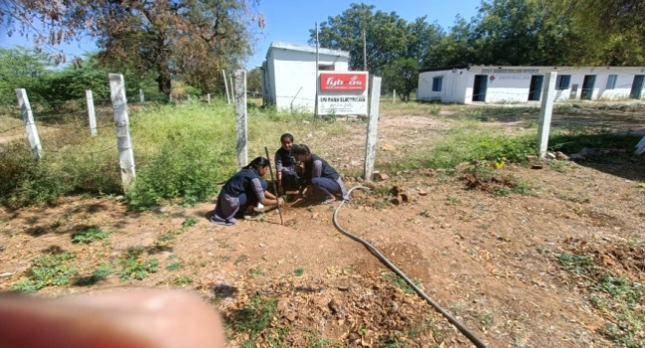

5. Evidence of Success
- Increased student participation in environmental activities.
- Visible improvement in campus cleanliness and greenery.
- Students developed environmental consciousness and civic responsibility.
- Positive appreciation from faculty and college administration.

6. Problems Encountered and Resources Required
Problems Encountered:
- Limited gardening tools and resources.
- Need for continuous maintenance of plants.
Resources Required:
- Saplings and watering facilities.
- Cleaning tools such as brooms and waste bins.
- Support from faculty and college administration.

7. Outcomes / Impact
- Creation of a clean and eco-friendly campus environment.
- Students develop environmental responsibility and teamwork skills.
- Increase in greenery and aesthetic beauty of the campus.
- Improved health and hygiene awareness among students.
- Strengthening the role of the Department of Economics in community and environmental initiatives.

2-BEST PRACTICE: FREE UNIFORM DISTRIBUTION
Department of Economics — Govt. Degree College, Mydukur

1. Introduction
The Free Uniform Distribution program aims to provide students with necessary academic uniforms at no cost. This initiative ensures equality among students, reduces financial burden on families, and promotes discipline and identity within the college environment.

2. Objectives
- Ensure equal access to college uniforms for all students.
- Reduce financial stress on economically weaker students.
- Promote a sense of unity and discipline among students.
- Encourage regular attendance and participation in college activities.
- Enhance the institution’s image by maintaining uniformity.

3. Stakeholders Involved
✔ Students
✔ College Administration
✔ Department of Economics Staff
✔ Uniform Suppliers/Manufacturers
✔ Local Government or Education Department (if funding support exists)

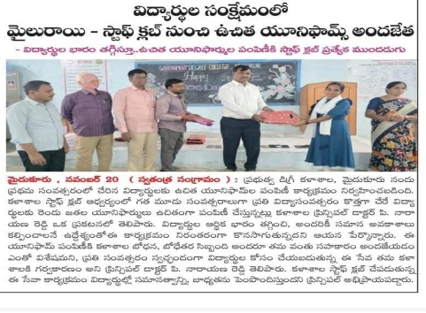

4. Best Practice Components

A. Identification of Beneficiaries
- Maintain a student database with socio-economic details.
- Prioritize students from low-income families.
- Ensure transparency in beneficiary selection.

B. Budget Planning & Funding
- Allocate funds from college or department budgets.
- Explore government schemes or CSR initiatives for support.
- Maintain records of expenditure for accountability.

C. Vendor Selection & Procurement
- Select reliable uniform suppliers for quality and timely delivery.
- Ensure standard sizing for all students.
- Include a feedback mechanism for quality improvements.

D. Distribution Process
- Schedule distribution days at the college premises.
- Use a token or ID-based system for orderly distribution.
- Provide replacement options in case of errors in sizing.

E. Record Keeping
- Maintain digital and physical records of distributed uniforms.
- Track number of beneficiaries and annual requirement.
- Use data for future planning and audit purposes.

F. Awareness & Participation
- Inform students about timelines and procedures.
- Encourage student volunteers to assist in distribution.
- Promote responsible use and maintenance of uniforms.

5. Economic and Social Benefits
📌 Reduces financial inequality among students
📌 Improves attendance and participation in college events
📌 Encourages discipline and unity
📌 Boosts student confidence and institutional pride
📌 Reduces peer pressure related to attire

6. Challenges and Solutions
Challenges | Solutions
Incorrect sizing | Conduct measurement sessions beforehand
Late procurement | Plan procurement schedules in advance
Misuse or damage | Educate students on care and responsibility
Limited funding | Seek government or NGO support

7. Recommendations
✔ Conduct annual needs assessment for uniform requirements.
✔ Maintain a continuous vendor relationship for quality and cost efficiency.
✔ Encourage feedback from students and staff to improve the program.
✔ Use digital tracking systems for better transparency.

8. Conclusion
The Free Uniform Distribution program is a sustainable and socially inclusive practice. It ensures equal opportunity, promotes discipline, and enhances the learning environment at the Department of Economics, Govt. Degree College, Mydukur.

Top of Form

Bottom of Form

